

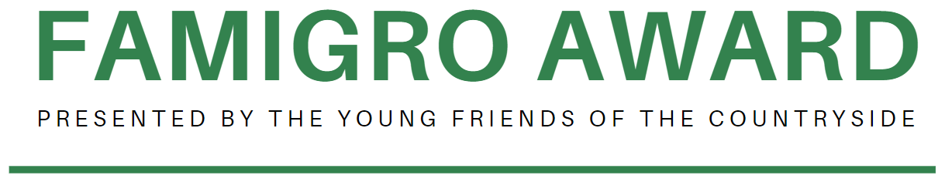

2025 EDITION

- Application Form –
Name of the project

Project in 1 sentence

Date

Foreword
Young Friends of the Countryside (YFCS) promotes the role of young people in preserving the future of Europe’s countryside and aims to provide them with the tools to do this in the best way possible.
Famigro is a private company belonging to the Grotenfelt family. It was founded by Karl Grotenfelt in 1985.
The Grotenfelt family represents more than 350 years of diversified landowning in Finland.
Description of the Award
Subject:
The Famigro Award is granted annually to a young European countryside entrepreneur that is making a special contribution to the rural economy and environment.
Eligibility criteria:
The applicant shall (be):
- A European/UK citizen or permanent resident, or
- A group of Europeans represented by one person
- Between the ages of 18 and 40
- Not have been awarded this prize previously
- Reapply if previously unsuccessful
The business should be:
- A for-profit business
- Registered and have its head office in the EU/UK
- show 2 years of financial figures
The project:
- Has been operational for at least 2 years
- Has a long-term scope and aims at future developments
- The business plan shows the development of one or more activities aiming at generating financial funds ensuring the continuity of the private enterprise
- Aims at developing innovative solutions for the creation and conservation of local economic development and fostering business opportunities - what is its social impact?
- Includes 2 years of full financial figures
- Is an example of good practice to other (rural) communities and is scalable and adaptable to different rural contexts

Selection criteria:
- Best practices and replicability
- The long-term vision of the project
- Novel and innovative ideas
- Projects that are scalable
- Solutions that favour the development of rural economies and foster business opportunities
- Projects that contribute to improving the environment
Prize description:
- A EUR 5,000 prize and diploma of recognition*
- Advertisement on the communication of the YFCS, FCS and ELO channels
- An article in the CountrySide Magazine (more than 4,000 readers)
- The opportunity to present the project at the FCS & YFCS General Assembly
*The jury may award more than one diploma of recognition if other projects are outstanding.
Deadline:
The deadline for the 2025 award application is February 28, 2025 (by noon, 12 pm CET).
Applications must be sent to the following e-mail address:
info@yfcs.eu

SECTION A
Administrative Information
Applicant/Representative of the applicant
Project Name

Legal Information on the Applicant
Full legal name of applicant |  | Legal Status
Full legal name of applicant |  | ☐Public
Full legal name of applicant |  | ☐Private
Full legal name of applicant |  | ☐Natural Person
Date of birth
Address
Town/City |  | Post code
Country
Email |  | Tel No.
Function in the Co.
Website

Legal Address of the Applicant
Street and No.
Town/City |  | Postcode
Country

Contact Person (if different from above)
Title |  | First Name
Surname
Address
Town/City |  | Post code
Country
Telephone No. |  | Fax No.
E-mail
Function in the Co.

Location of the project area (if different from above)
Name
Address
Town/City |  | Postcode
Country
Telephone No. |  | Fax No
E-mail |  | Website

Other members of the team (optional)
Legal Name |  | Legal Status
Legal Name |  | ☐Public
Legal Name |  | ☐Private
Legal Name |  | ☐Natural Person
Date of birth
Address
Town/City |  | Post code
Country
Position in the company

SECTION B
Project vision & objectives
General vision of the project (max. 500 characters)

Main principles on which the project focuses (max. 500 characters)

Executive Summary of the Project
Project outlines
Project Timeframe

Project Area (including history & features in max. 500 characters)

Short-term objectives (max. 250 characters)

Long-term objectives (max. 250 characters)

Full Financial figures - 2 years of financial accounts

Business Model
Business Model - including economic feasibility of the project in the
long term. (max. 1800 characters)

General Description of the Project
Project Description - include social impact (max. 1800 characters)

Letter of motivation
Letter of motivation - A letter addressed to the jury explaining why the project fits the aims of this award. (max. 1 page)
SECTION C
Annexes
Key Figures of the Business Plan

Acknowledgement of Receipt
Young Friends of the Countryside - YFCS
Rue de Trèves, 67
B – 1040 Brussels
Name of Applicant*

Contact Person*

Email*

Title of the Project*

*to be filled out by the applicant

Sir / Madam,

We acknowledge receipt of your proposal for which we thank you.
Your proposal will be examined by the members of the Jury, with respect to its eligibility. Those projects declared eligible will then undergo an evaluation procedure by the Jury.
We will let you know the final decision as soon as it has been taken.

Yours faithfully,

Date:

